Facility : map
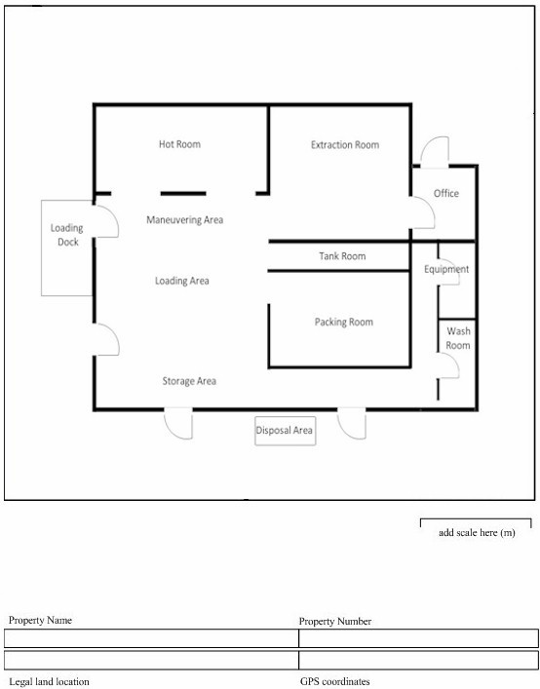
Beekeepers : delete the sample image on the template and add own facility map

